# Goods Delivery and Shortest Route Problem

## Phase 1: Cargo Loading – Fractional Knapsack

## Objective

* **Select goods to load into the truck (with max weight limit) to maximize total value.** You can take part of a good (fractional allowed).

## Steps of the Greedy Fractional Knapsack Algorithm

1. **Calculate value-to-weight ratio** for each good:

Ratio = $\frac{Value}{Weight}$

1. **Sort goods** in descending order by this ratio (greediest first).
2. **Iteratively add goods** to the truck:
   * Take the whole item if possible.
   * If you can't fit the whole item, take as much as fills the truck's remaining space.
3. **Stop when the truck is full.**

## Example Table

Let's assume these example goods and a max truck weight of 10 kg:

| **Good** | **Value ($)** | **Weight (kg)** | **Value/Weight** |
| --- | --- | --- | --- |
| 1 | 50 | 5 | **10.0** |
| 2 | 60 | 10 | 6.0 |
| 3 | 140 | 20 | 7.0 |

Compute ratios and sort: Good 1 (10), Good 3 (7), Good 2 (6)

## Loading Steps Table

| **Step** | **Good Added** | **Amount Taken** | **Value Added** | **Cumulative Weight** | **Cumulative Value** |
| --- | --- | --- | --- | --- | --- |
| 1 | Good 1 | Full (5 kg) | 50 | 5 | 50 |
| 2 | Good 3 | 5 kg (of 20) | 35 | 10 | 85 |

We ONLY have 5 kg space left after the first item. So, we take 5/20 of Good 3.

**Final answers:**

* Truck loaded: Good 1 (full), Good 3 (fractional)
* **Total Value:** 50+35=85
* **Total Weight:** 10 kg

## Fractional Knapsack Flowchart

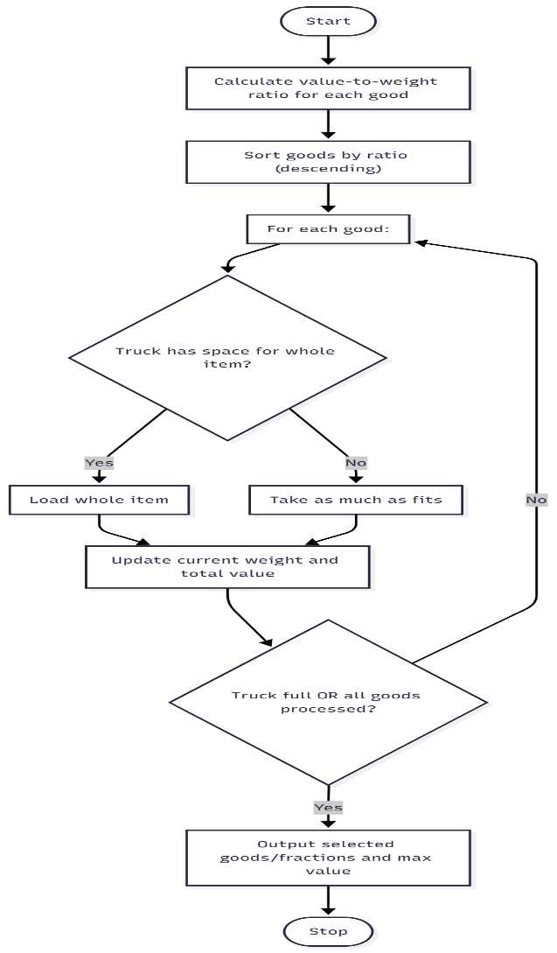

## Phase 2: Route Planning – Traveling Salesman Problem (TSP)

## Objective

* **Minimize total delivery route cost.**
* Visit each city (A, B, C, D, E) once and return to the starting city (full loop).

## Explanation

For 5 cities: You need to find the order in which to visit all 5 so that the total travel cost/distance is as low as possible. This isn't "just go shortest to next"—you have to consider the complete tour, because the shortest edge-by-edge path might not be the overall cheapest tour.

## Example Cost Matrix

Suppose this is your travel cost matrix:

|  | **A** | **B** | **C** | **D** | **E** |
| --- | --- | --- | --- | --- | --- |
| **A** | 0 | 10 | 15 | 20 | 25 |
| **B** | 10 | 0 | 35 | 25 | 17 |
| **C** | 15 | 35 | 0 | 30 | 28 |
| **D** | 20 | 25 | 30 | 0 | 22 |
| **E** | 25 | 17 | 28 | 22 | 0 |

## How to Find the Shortest Tour (without Coding)

* Total unique tours for 5 cities: (5−1)!/2=12(5-1)!/2 = 12(5−1)!/2=12 (if you treat A-B-C-D-E as same as E-D-C-B-A, ignore starting city for this math).
* List or imagine all possible city orderings, add up the cost for each full loop, and pick the minimum.

For example:

1. **A-B-E-D-C-A**
   * A→B: 10
   * B→E: 17
   * E→D: 22
   * D→C: 30
   * C→A: 15
   * **Total:** 10+17+22+30+15 = 94
2. **A-C-E-B-D-A**
   * A→C: 15
   * C→E: 28
   * E→B: 17
   * B→D: 25
   * D→A: 20
   * **Total:** 15+28+17+25+20 = 105

Keep going for all (n-1)! = (5 - 1)! = 24 permutations.

## How Do You Know Which Is Shortest?

* The shortest tour will have the lowest total sum.
* This process “eliminates” all longer tours by comparing total routes. You're literally proving "no other tour is shorter" by checking everything.

**Let’s say after trying all valid orders, you find:**

* **Shortest Tour:** A-B-E-D-C-A
* **Minimum Cost:** 94

## High-Level TSP Flowchart

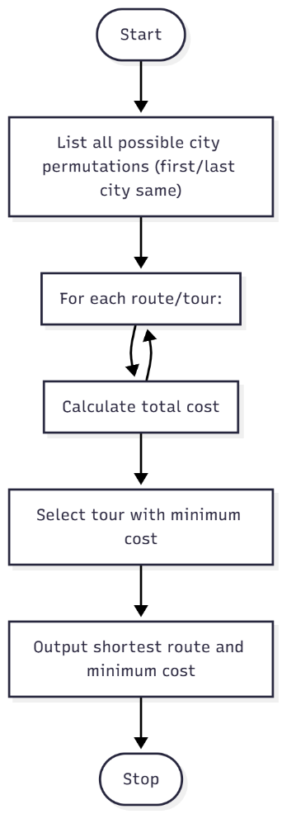

## To Summarize

* **Fractional Knapsack:** Greedily load items by value/weight ratio until the truck is full. Plug in your good's list to test yourself.
* **TSP:** List every delivery route, add their costs, and pick the absolute shortest. The brute-force way is guaranteed for 5 cities.